Mathematics Specialist Unit 3

Test 1: Complex Numbers and Polynomial Factorization
Solutions

Student Name: _________________________

Section I – calculator-free section

- Determine exact expressions in the form $x+yi$ for each of the following:

- $\frac{\overline{3+i}}{{\left(1-2i\right)}^{2}}$ (3 marks)

$=$ $\frac{3-i}{-3-4i}$

$=$ $\frac{\left(3-i\right)}{\left(-3-4i\right)}\frac{\left(-3+4i\right)}{\left(-3-4i\right)}$

$=$ $\frac{-5+15i}{25}$

$= -$ $\frac{1}{5}$ $+$ $\frac{3}{5}$ $i$

- ${\left(-2\sqrt{3}+2i\right)}^{3}$ (3 marks)

$={(4cis150°)}^{3}$

$=4^{3}cis450°$

$=64i$

- The polynomial $p\left(z\right)=z^{4}+mz^{3}+3z^{2}+10z+50$ , where m is a real constant. The equation $p\left(z\right)=0$ has a solution of $z=1+2i$. Determine the value of $m$ and the remaining solutions of $p\left(z\right)=0$.
(5 marks)

$z_{1}=1+2i ⇒ z_{2}=1-2i$

$z_{1}+z_{2}=2$ and $z_{1}z_{2}=1^{2}+2^{2}=5 ⇒ z^{2}-2z+5$ is a factor of p(z)

$\begin{matrix}z^{2} & 6z & 10\end{matrix}$
$$z^{4}$$ | 6$z^{3}$ | $$10z^{2}$$
$$-2z^{3}$$ | $$-12z^{2}$$ | $$-20z$$
$$5z^{2}$$ | 30z | 50
$\begin{matrix}z^{2} \\ -2z \\ 5\end{matrix}$

$∴ m=-2+6=4$ and $z^{2}+6z+10=0$

${(z+3)}^{2}-9+10=0$

${(z+3)}^{2}=-1$

$z+3=±i$

$z=-3±i$

$m=4$ and the remaining solutions are $z_{2}=1-2i , z_{3}=-3+i , z_{4}=-3-i$

- Two of the solutions to the equation $z^{k}=Ai$ , $k∈Z^{+}$ , $A∈R$ are $z=\sqrt{2}cis$ $\left(-\frac{π}{10}\right)$ and $z=\sqrt{2}cis\left(\frac{3π}{10}\right)$.

- State one other solution to the equation. (2 marks)

$\frac{3π}{10}-\left(-\frac{π}{10}\right)=\frac{4π}{10}$

possible other arguments: $\frac{3π}{10}+\frac{4π}{10}=\frac{7π}{10}$

$-\frac{π}{10}-\frac{4π}{10}=-\frac{5π}{10}=-\frac{π}{2}$

$-\frac{π}{10}-2×\frac{4π}{10}=-\frac{9π}{10}$

$∴ possible other solutions$ $z=\sqrt{2}cis$ $\left(\frac{7π}{10}\right),$ $\sqrt{2}cis\left(-\frac{π}{2}\right), \sqrt{2}cis$ $\left(-\frac{9π}{10}\right)$

- Determine the minimum value of $k$ and the exact value of $A$ in this circumstance.
(3 marks)
max angle between solutions $=$ $\frac{4π}{10}=\frac{2π}{5} ⇒ 5$ solutions

$∴ \min{k=5}$
$Ai={\left(\sqrt{2}cis \left(-\frac{π}{10}\right)\right)}^{5}$

$={\sqrt{2}}^{5}cis \left(-\frac{5π}{10}\right)$

$=4\sqrt{2}cis\left(-\frac{π}{2}\right)$

$=-4\sqrt{2}i$

$∴ A=-4\sqrt{2}$

- $f\left(x\right)=x^{3}+x^{2}-7x+4$

- Rewrite $\frac{f(x)}{x-2}$ in the form $p\left(x\right)+$ $\frac{r}{x-2}$ for $p\left(x\right)$ a polynomial of degree 2 and $r$ a real number.
(3 marks)
$\frac{f(x)}{x-2}$ $=$ $\frac{x^{3}+x^{2}-7x+4}{x-2}$ $=$ $\frac{x^{2}\left(x-2\right)+3x^{2}-7x+4}{x-2}$

$=$ $\frac{x^{2}\left(x-2\right)+3x(x-2)-x+4}{x-2}$

$=$ $\frac{x^{2}\left(x-2\right)+3x(x-2)-1(x-2)+2}{x-2}$

$=x^{2}+3x-1+$ $\frac{2}{x-2}$

- Hence, or otherwise, find $f(2+i)$ in the form $x+yi$. (3 marks)

$\frac{f(x)}{x-2}$ $=x^{2}+3x-1+$ $\frac{2}{x-2}$

$∴ f\left(x\right)=\left(x-2\right)\left(x^{2}+3x-1\right)+2$

$f\left(2+i\right)=\left(2+i-2\right)\left({\left(2+i\right)}^{2}+3\left(2+i\right)-1\right)+2$

$=i\left(3+4i+6+3i-1\right)+2$

$=i\left(8+7i\right)+2$

$=-5+8i$

End of Section I
Section II – calculator-assumed section

- Consider the complex equations
$\left|z+3-2i\right|=3$ and $\left|z\right|=\left|z+4-2i\right|$

- On the set of axes below neatly sketch the graphs of these complex equations

(4 marks)
circle, centre $\left(-3,2\right)$ radius 3 and the perpendicular bisector to the line segment joining $(-4,2)$ to the origin.

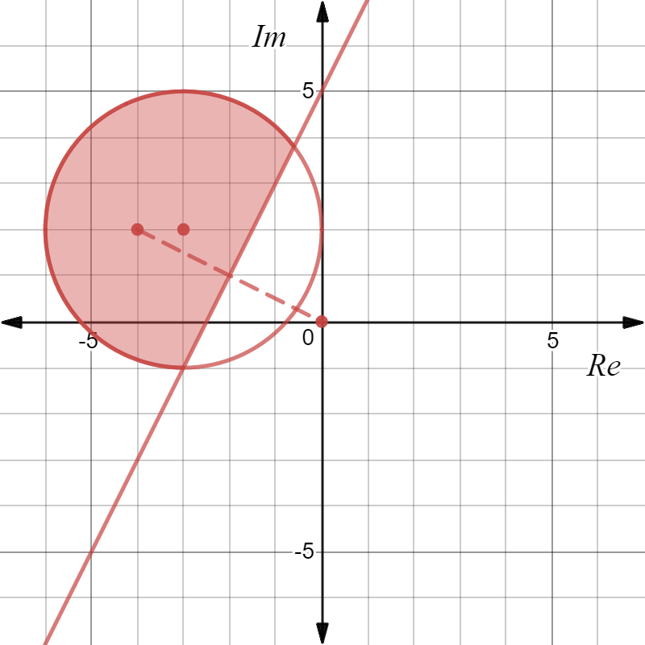

- On your diagram shade in the region which satisfies

$\left|z+3-2i\right|≤3 ∩ \left|z\right|≥\left|z+4-2i\right|$ (2 marks)

Shade inside the circle and above the line.

- $h\left(z\right)=z^{7}+iz^{4}-9iz^{3}+9$

- Show that $h\left(z\right)=(z^{4}-9i)(z^{3}+i)$ (1 mark)

RHS $=(z^{4}-9i)(z^{3}+i)$

$=z^{7}+iz^{4}-9iz^{3}-9i^{2}$

$=z^{7}+iz^{4}-9iz^{3}+9$

$=h\left(z\right)$

$=$ LHS

- Hence find all solutions to the equation $h\left(z\right)=0$ expressing your answers in the form $rcisθ$ where $r≥0$ and $-π<θ≤π$ .
(6 marks)
$h\left(z\right)=0 ⇒ z^{4}=9i$ or $z^{3}=-i$

$∴ z^{4}=9cis$ $\frac{π}{2}$ or $z^{3}=1cis\left(-\frac{π}{2}\right)$

$z^{4}=9cis\left(\frac{π}{2}+2nπ\right)$ or $z^{3}=1cis\left(-\frac{π}{2}+2nπ\right)$

$z=\sqrt{3}cis\left(\frac{π}{8}+\frac{2nπ}{4}\right)$ or $z=cis\left(-\frac{π}{6}+\frac{2nπ}{3}\right)$

$z=\sqrt{3}cis\left( \frac{π}{8} \right)$, $\sqrt{3}cis\left( \frac{5π}{8} \right), \sqrt{3}cis\left(-\frac{7π}{8}\right), \sqrt{3}cis\left(-\frac{3π}{8}\right)$

or $z=cis\left(-\frac{π}{6}\right), cis\left( \frac{π}{2} \right), cis\left(-\frac{5π}{6}\right)$

- A subset of points $z$ in the complex plane form a circle with centre C and radius 4 units as shown.
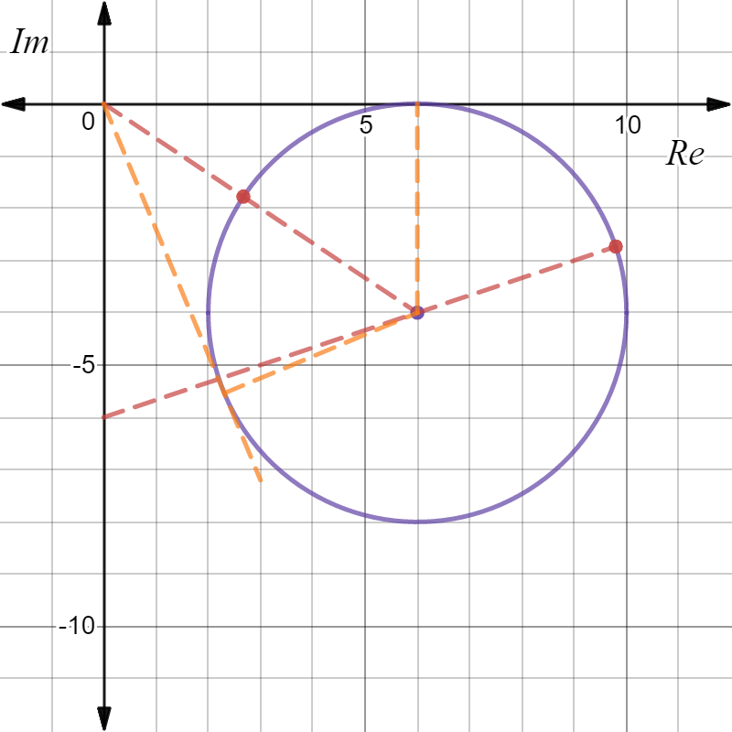

A
B

C

- Mark the position on the plane where $\left|z\right|$ is a minimum, clearly label this point A and give this minimum value exactly.
(2 marks)
Min $\left|z\right|=\sqrt{6^{2}+4^{2}}-4=\sqrt{52}-4=2\sqrt{13}-4$

- Mark the position on the plane where $\left|z+6i\right|$ is a maximum, clearly label this point B and give this maximum value exactly.
(2 marks)
Max $\left|z+6i\right|=\max\left|z-(-6i)\right|=$ max distance of $z$ from $(0,-6)$

$=\sqrt{2^{2}+6^{2}}+4=\sqrt{40}+4=2\sqrt{10}+4$

- Determine to three decimal places the minimum value of $θ=arg\left(z\right), -π<θ≤π$.

(3 marks)
Min $\arg\left(z\right)=-{2tan}^{-1}{\frac{4}{6}}$=$-1.176$radians ($-67.380°)$

- If $u=rcisθ , r>0 -π<θ≤π$ and $w=1+\sqrt{3}i$ express each of the following in terms of $r$ and $θ$.

- $-u$ (2 marks)

$-u=cisπ.rcisθ$

$=rcis(π+θ)$
$=rcis(θ-π)$

- $uw$ (2 marks)

$uw=rcisθ.2cis$ $\left(\frac{π}{3}\right)$
$=2rcis(θ+$ $\frac{π}{3}$ $)$

$=2rcis(θ-$ $\frac{5π}{3}$ $)$

- $\frac{i\overline{u}}{w}$ (2 marks)

$\frac{i\overline{u}}{w}$ $=$ $\frac{cis\left(\frac{π}{2}\right)rcis(-θ)}{2cis \left(\frac{π}{3}\right)}$

$=$ $\frac{r}{2}$ $cis($ $\frac{π}{6}$ $- θ)$

- Assume $x=cisθ$.

- Use De Moivre’s theorem to prove that $x^{k}-$ $\frac{1}{x^{k}}$ $=2isin(kθ)$ (3 marks)
LHS $=$ $x^{k}-$ $\frac{1}{x^{k}}$
$= {(cisθ)}^{k}-$ $\frac{1}{{(cisθ)}^{k}}$
$= {(cisθ)}^{k}- {(cisθ)}^{-k}$

$= cis\left(kθ\right)-cis(-kθ)$ by De Moivre’s theorem

$= \cos\left(kθ\right)+isin\left(kθ\right)-\left[cos\left(-kθ\right)+sin(-kθ)\right]$

$=$ $\cos\left(kθ\right)+isin\left(kθ\right)-\left[\cos\left(kθ\right)-isin\left(kθ\right)\right]$

$=$ $\cos\left(kθ\right)+isin\left(kθ\right)-\cos\left(kθ\right)+isin\left(kθ\right)$

$=2isin(kθ)$

$=$RHS

- Expand ${\left(x-\frac{1}{x} \right)}^{3}$ and use the outcome in part (a) above to prove that

$3sinθ-4\sin^{3}θ=sin3θ$. (4 marks)

${\left(x-\frac{1}{x} \right)}^{3}=x^{3}-3x+$ $\frac{3}{x}$ $-$ $\frac{1}{x^{3}}$

$=$ $x^{3}-$ $\frac{1}{x^{3}}-3(x-$ $\frac{1}{x}$ )

$∴ {(2isinθ)}^{3}=$ $2isin3θ-3.2isinθ$

$-8i\sin^{3}θ=2i(sin3θ-3sinθ)$

$∴ -4\sin^{3}θ=sin3θ-3sinθ$

$3sinθ-4\sin^{3}θ=sin3θ$

End of Test

